**SECTION JF**

**LUBRICATING OIL FILTER**

CONTENTS

|  |  |
| --- | --- |
|  | chapter |
| Description .. | 1 |
| Servicing | 2 |
| Servicing Change-over Valve | 3 |

CHAPTER 1  
DESCRIPTION

The duplex lubricating oil filter comprises two separate filtration units secured to a common ported head casting (22). A change-over valve fitted to the head casting enables one filtration unit to be serviced while the other is in use. The change-over valve is fitted with a handle and pointer (6) to indicate the filtration unit in use. The positions on the indicator plate from left to right are:-

1. Prime right hand filter, left hand filter in use.
2. Both filters in use.
3. Prime left hand filter, right hand filter in use.

The handle and pointer are located in the indicated position by a plunger and spring (17).

Oil enters the filter via the inlet port and centre tube (26), passes through the filter element and is returned to the engine via the outlet port.

A pressure differential indicator is fitted between the clean and dirty sides of the filter to indicate element condition. In normal operation with clean elements the difference in pressure will be very low and the indicator will show a complete ’GREEN' segment. As the pressure differential increases due to the gradual fouling of the elements the indicator will rotate to show 'GREEN' and 'RED'. Should the difference in pressure reach 0.70 bar (10 lbf/in2), the indicator will show a complete 'RED' segment and the filter elements MUST be changed. Readings should only be taken with the engine running at normal operating speed and temperature.

CHAPTER 2

SERVICING

Dismantling

1. Turn valve handle and pointer (6) to the filter unit to be used. This will isolate the filter unit to be serviced.
2. Place a suitable sized container beneath the filter to be serviced, slacken vent plug (3), remove drain plug (21) and drain the filter.
3. Remove nuts (1) and bolts (2) and carefully remove top cover (4). Remove and discard 'O' ring (31).
4. Remove cartridge retainer (33) and withdraw cartridge elements (24) and (30) and locator (27). Discard the cartridge elements.

Cleaning and Inspection

NOTE The cartridge element is of the disposable type and must not be dismantled or cleaned for further use.

1. Thoroughly clean all joint faces.
2. Remove magnets and cage (28) and pull cage off magnet. Clean the magnets in a suitable solvent and replace them in their cage.
3. Refit magnets and cage between nuts (29) so that the distance between the top of the magnet cage and the top of the centre tube stud is between 69 and 71 mm.
4. Clean the interior of the case and wash all metal components in a suitable solvent. Dry thoroughly before use.
5. Check the lower case seal for leaks.
6. Check tightness of setbolts (5), they should be 20 kg.m (148 lb.ft).

Assembly

NOTE All joints and 'O' rings must be fitted dry.

1. Place lower cartridge element (24) in position over centre tube (26) ensuring that it seats correctly.
2. Fit locator (27) over centre tube (26) and onto lower cartridge element (24) ensuring that it seats correctly.
3. Fit upper cartridge element (30) into position on the locator ensuring that it seats correctly.
4. Fit cartridge retainer (33) onto the upper cartridge element and screw down fully onto centre tube stud (32).
5. Fit a new 'O' ring (31) into the groove in top cover (4).
6. Fit top cover (4) to casing (25) and secure with bolts (2) and nuts (1).
7. Using a new washer fit and secure drain plug (21).
8. To vent the system, loosen vent plug (3), open priming valve (7).
9. Close the air vent and priming valve when a steady bleed of air free oil is emitted.

LIMITED RIGHTS LEGEND

4

USE, DUPLICATION OR DISCLOSURE OF THIS INFORMATION WHICH IS THE PROPERTY

OF GEC ALSTHOM DIESELS LIMITED BY THE U.S. GOVERNMENT OR BOLLINGER IS SUBJECT TO THE RESTRICTIONS SET FORTH IN DOD FAR SUPP 252.227-7013 (a) 15.

CHAPTER 3

CHANGE-OVER VALVE

NOTE The change-over valve unit mounted in the filter head casting is a simple plug assembly. No maintenance is required other than to renew the 'O' rings during major overhaul.

1. Drain the lubricating oil filters ( Chapter 2).
2. Remove retaining capscrews (9) and remove end cover (10). Discard 'O’ ring (11).
3. Remove setbolt (15) and plain washer, and remove handle and pointer (6). Remove key (16).
4. Remove retaining capscrews (20) and remove front cover (18). Discard 'O' ring (13).
5. Using a suitable wooden drift, push valve plug (12) from the head casting. Discard 'O' rings (14) and (19).

Assembly and Fitting

NOTE All joints and 'O' rings must be fitted dry.

1. Fit new 'O' rings (14) and (19) to valve plug (12).
2. Using a new 'O' ring (11), fit end cover (10) and secure with capscrews (9).
3. Smear 'O' rings with petroleum jelly and insert valve plug (12) into head casting (22), taking care not to damage the 'O' rings.
4. Using a new 'O' ring (13), fit front cover (18) and secure with capscrews (20).
5. Refit valve handle and pointer (6) to the valve plug ensuring that it fits on key (16)

and secure with setbolt (15) and plain washer.

1. Prime and vent the system.

Key To Numbers

1. Nut
2. Bolt
3. Vent plug
4. Top cover
5. Setbolt
6. Handle and pointer
7. Priming valve
8. Change-over valve
9. Capscrew
10. End cover
11. 'O'ring
12. Valve plug
13. 'O' ring
14. 'O’ ring
15. Setbolt
16. Key
17. Plunger and spring
18. Front cover
19. 'O' ring
20. Capscrew
21. Drain plug
22. Head casting
23. 'O’ ring
24. Lower cartridge element
25. Casing
26. Centre tube
27. Locator
28. Magnets and cage
29. Plain Nut
30. Upper cartridge element
31. 'O'ring
32. Centre tube stud
33. Cartridge retainer

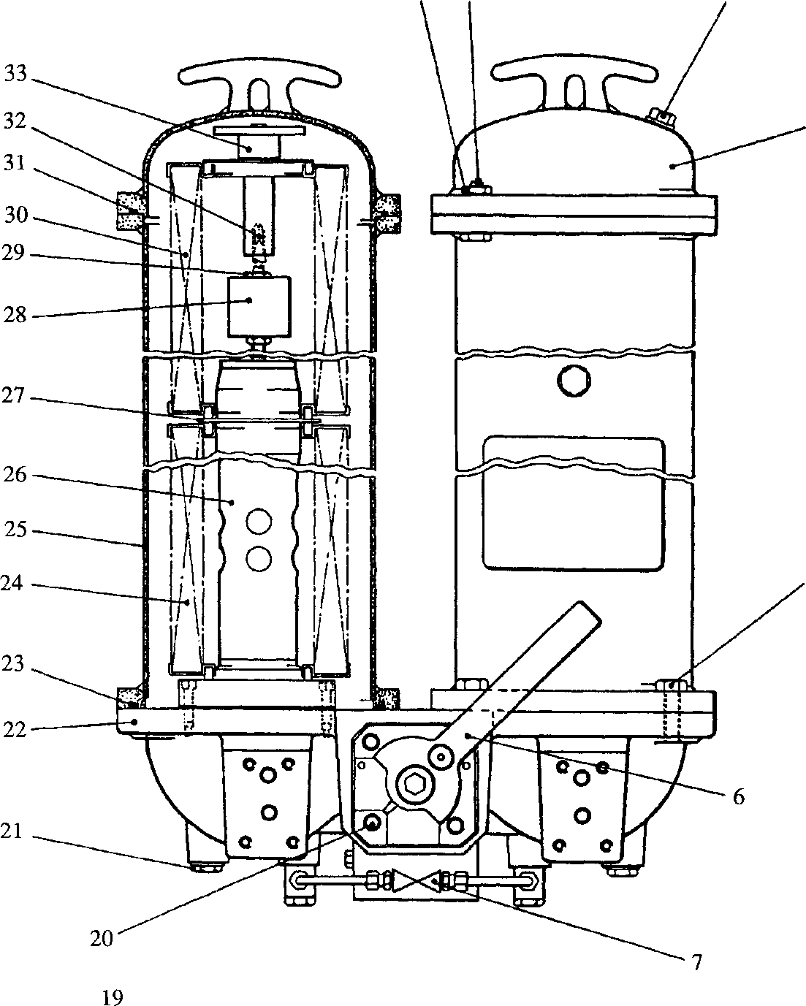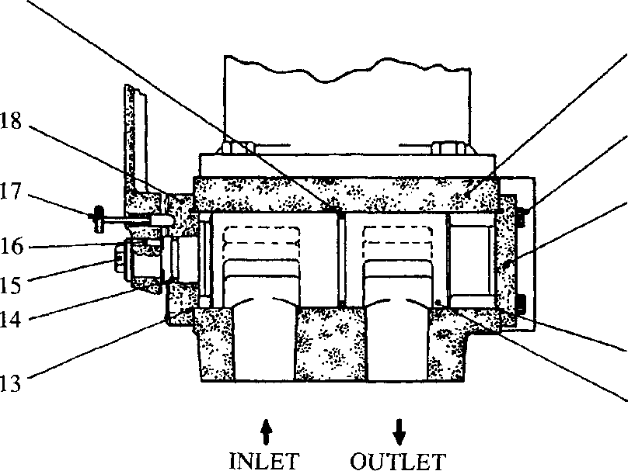

**9**

10

11

•12

**SPD00500**

Lubricating oil filter